I am completing the professional website.

After looking at the professional and portfolio website requirements for this project I chose the professional website for a few reasons. The main reason for developing the professional website is to have another resource to direct potential clients to for my consulting business when they want to learn more about me. Another reason I chose the professional website over the portfolio website is this is only my second course in my Education Specialist degree. I do not feel like I have enough material for a portfolio yet.

**Home Page**

Welcome! Cindy Schluckebier graduated from Central Methodist University with a Bachelor's degree in Management. She worked as an entrepreneur for around 10 years before entering education. Cindy has taken her real world experiences from growing up in family business and is now facilitating learning at a student operated business, All Things Independence, in Independence, Missouri. Cindy received her Master’s degree in Education Technology from William Woods University and is currently working on her specialist’s degree at the University of Missouri.

In addition to teaching, Cindy is passionate about helping teachers grow and love their job. When coaching teachers Cindy takes an empathetic approach to leading teachers. She enjoys empowering teachers to implement a curriculum that engages and empowers their students to higher levels of achievement.

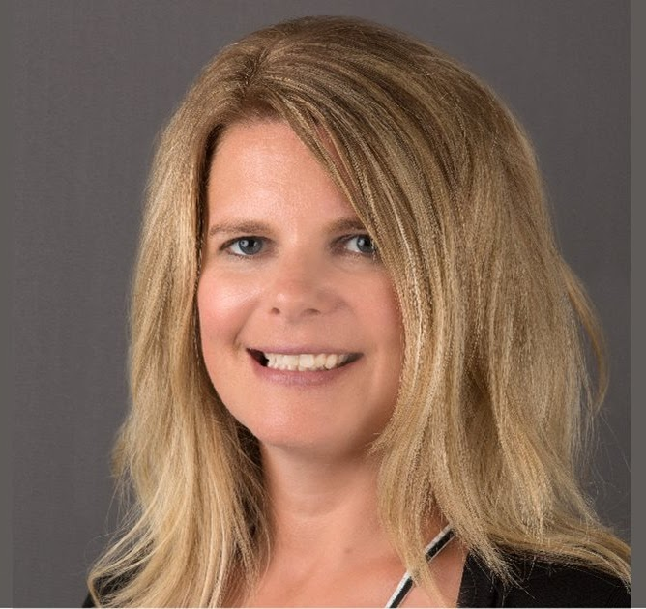

**Experience Page**

Since the fall of 2016 I have been a business teacher in the Independence School District. Currently, I facilitate learning at two student operated businesses with juniors and seniors through an entrepreneurship capstone course. Through this experience students embrace the entrepreneurial spirit through real businesses and gain key entrepreneurial skills such as critical thinking, problem-solving, communication, risk-taking and teamwork. So far in my career this by far is my favorite position. It has taken all of my past experiences and passions and molded them together into one position. I have the opportunity here to use my past experience to help empower students of the ISD to be more entrepreneurial.

I began my teaching career in New Franklin, Missouri. I taught there from August 2005 to May 2016. My tenure at New Franklin brought significant professional growth. I became a certified eMINTS teacher and later an Affiliate eMINTS trainer for the district. In addition to my teaching schedule I delivered professional development to my peers.

From 1999 to 2009 I was employed at my family’s clothing store in Fayette, Missouri. Clatworthy’s was in business for 73 years. I was the third generation to operate this business with my dad. Here I was in charge of merchandising, purchasing, and customer service. I had a dream with my dad of incorporating a student operated business with retail. We hosted students at our store who were interested in business and entrepreneurship as interns through the local high school. Little did I know about 10 years later my dream would come true.

**Professional Accomplishments Page**

**Degrees**

Bachelors in Management; Central Methodist University (1996)

Master’s in Education Technology; William Woods University (2018)

**Certificates**

eMINTS Teacher (2009)

Master Trainer Intel Thinking with Technology (2010)

Affiliate eMINTS Trainer (2016)

**Graduate Courses Completed**

**Course University Date**

ISLT 9417 Action Research Univ of MO Spring 2020

EDU 589 Teaching and Technology Capstone WWU Spring 2018

TRS 500 EMINTS I-III WWU Spring 2018

EDU 561 Instructional Design w/ Technology WWU Fall 2017

EDU 520 Research Design WWU Summer 2017

EDU 590 Appraisal of Student Learning WWU Summer 2017

EDU 543 Teaching/Learning New Digital Landscape WWU Spring 2017

EDU 500 Current Issues WWU Spring 2017

**Checklist of 5 Critical Web Development Issues**

User and usability

* Did I present as much critical information “above the fold”?
* Did I group related items and limit the number of groups on each page?
* Did I include a header that identified the site and provided a navigation bar and links to utilities?
* Did I use current navigation conventions, like a logo to click on to go to the home page?
* Do all links work?
* Are pages named appropriately so the user isn’t frustrated and can't find what they are looking for quickly?

Cross-browser compatibility

* I tested my web pages on Internet Explorer, Firefox, Safari, and Chrome.
* I have tested my web pages in newest release browsers as well as older versions that are still commonly used.

User accessibility

* I will do more research using the sites given on pg. 35 of our text for this course to help learn more about making my site usable to all.
* I have developed the website so the content is still usable if images, CSS, and JavaScript are disabled.

Search engine optimization

* The title of the website is appropriate for SEO.
* Structural elements within my website are coded appropriately for SEO.
* I will do independent research on SEO.

Responsive Web Design

* Design for desktop first; then test on mobile.
* Consider building a separate website for mobile users if it does not integrate well.

**Design Guidelines**

Step 1: Define the audience and set the goals

* My target audience is clearly defined as prospective clients of K12 Perform.
* The goals of the website are clearly stated

Step 2: Develop the site map

* I have clearly developed a site map that includes all web pages
* I have clearly identified in the second level of the site map as any links in the navigation bar, and contents below that level represent the pages that are accessed via those links.
* I used a simple drawing program like Visio to create my site map

Step 3: Wireframe the critical pages

* I have created wireframes of my home page and at least one primary content page.

Step 4: Illustrate the critical pages

* I used Photoshop to illustrate the home page and one primary content page.